Multiple Choice:

1. B 2. D 3. C 4. C 5. D 6. E 7. C

8. B 9. B 10. B 11. E 12. C 13. D 14. E

15. C 16. D

Free Response

1)

|  |  |  |  |  |  |  |  |  |  |  |  |
| --- | --- | --- | --- | --- | --- | --- | --- | --- | --- | --- | --- |
| 4th Grade | | | | |  | 7th Grade | | | | | |
|  |  |  |  |  | 0 | 1 |  |  |  |  |  |
|  |  |  |  |  | 0 |  |  |  |  |  |  |
|  |  |  |  | 2 | 1 | 2 |  |  |  |  |  |
|  |  |  | 8 | 5 | 1 | 5 | 8 | 8 |  |  |  |
|  |  | 2 | 0 | 0 | 2 | 0 | 3 | 3 | 4 |  |  |
|  | 9 | 8 | 6 | 5 | 2 | 5 | 7 | 8 |  |  |  |
|  |  |  | 2 | 1 | 3 | 0 | 0 | 1 | 3 | 3 | 3 |
| 9 | 7 | 6 | 5 | 5 | 3 | 5 | 6 |  |  |  |  |
|  |  |  | 2 | 0 | 4 |  |  |  |  |  |  |

2) Both 4th grade and 7th grade distributions of reading scores are unimodal and skewed left. The 4th graders have a higher median score of 30 points than the 7th graders median score of 26 points. The 4th grade scores are more spread with an IQR of 14.5 points than the 7th graders with an IQR of 13 points. The range of the 4th graders is (12, 42) points, which is smaller than the range of the 7th graders, which is (1, 36) points.

3)

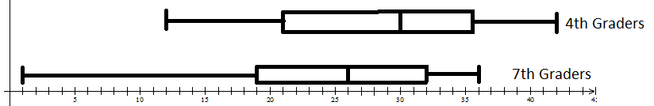

READING SCORES

4)

(a)

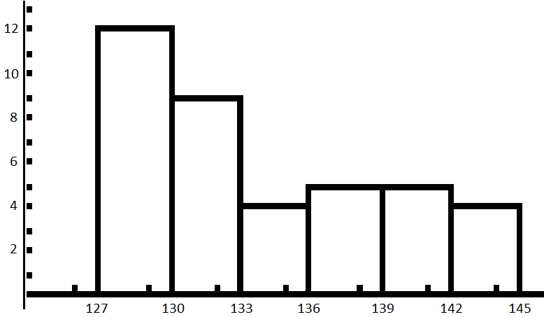

#

Times (mins)

(b) The cummulative frequency histogram would be left skewed, and would keep increasing as the x-variable increased.

(c) The distribution of winning times for men in the Boston Marathon is skewed right and unimodal. The center is at the median of 132 minutes. The IQR is 8 minutes. The range is (127, 144) minutes.

5) Mean = 167.67 lbs St. Dev. = 33.38 lbs

6) Min = 110 Q1 = 138.5 Med = 166.5 Q3 = 188 Max = 280

 DATA

7.) LF = 138.5 – 1.5(49.5) = 64.25 No lower outlier

UF = 188 + 1.5(49.5) = 262.25 There is one upper outlier at 280.

8) The median and IQR would be more appropriate since there is an upper outlier.

9) N(266, 16)

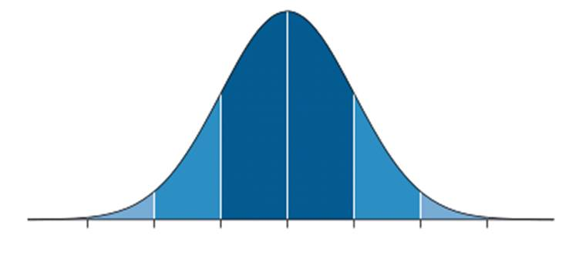

218 234 250 266 282 298 314

10) P(X > A) = 0.16 A = 282 days

11) 218 to 314 days *(3 std. deviations above and below)*

12) P(X < B) = 0.025 B = Less than 234 days

13) 

14) P(x < 257) = 28.7%

15) P(x > 280) = 19.08%

16) P(260 < x < 270) = 24.49%

17) P(X < C) = 0.90 C = 286.505 days

18) P(X < D) = 0.25 D = 255.208 days

19) N(1500, 75)

(a) P(x < 1350) = 2.28%

(b) P(x > 1700) = 0.38%

(c) P(1600 < x < 1780) = 9.11%

(d) P(X < A) = 0.78 A = 1557.91 hours

(e) Z = invNorm(0.05, 0, 1) = -1.645 

 hours

(f) Z = invNorm(0.05) = -1.645 

 hours

20) N(12.2,0.5)

(a) P(X > 13) = 5.48%

(b) P(X < A) = 0.35 A = 12.007 oz.

(c) P(X < A) = 0.15 A = 11.68 oz

P(X < B) = 0.85 B = 12.72 oz.

21) (a)

|  |  |  |  |
| --- | --- | --- | --- |
|  | Always wear glasses | Sometimes wears glasses | Never wear glasses |
| Boys | 40 | 48 | 161 |
| Girls | 36 | 55 | 144 |

(b) Always = 15.7%

Sometimes = 21.3%

Never = 63.02%

(c) P(N|B) = 67.4% of boys never wear glasses.

(d)

Boys Girls

Always 16.1% 15.3%

Sometimes 19.3% 23.4%

Never 64.7% 61.3%

(e) There does not appear to be an association between sex of the student and whether they wear glasses or not. The same percents of each gender are seen in each type of glasses wearing. For example, there are 16.1% boys that always wear glasses, and there are 15.3% girls that always wear glasses. These are almost the same, showing that there is no association between gender and glasses wearing.